**Map:**

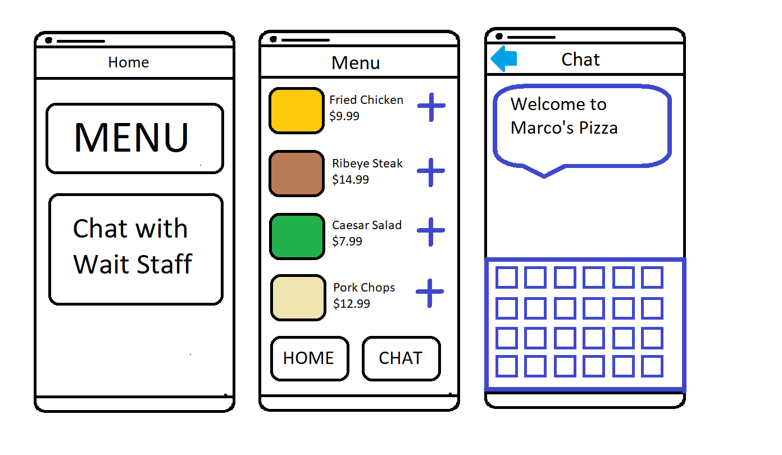

**Scenarios:**

Jimmy, a college sophomore, is going on a date with Sarah to a French restaurant called La Belle Helene. Both Jimmy and Sarah are deaf and communicate with sign language. Their interactions with waiters are always awkward because they have to ask for a pen and paper and write stuff down to communicate. Jimmy chose La Belle Helene because he knows they offer an app that lets you order and communicate with the waiter all through his phone. He makes a reservation through the app for 6:30 pm. He arrives with Sarah and they look through the menu in the app and make their order. During the meal, Sarah finishes her drink early and wants a refill. She opens the app and goes to the Chat section and types a message to their waiter asking for a refill. After they finish eating and are ready to leave, the payment and tip are all processed through the app.

Rene, a waitress at La Belle Helene, started her shift 2 hours ago. It’s Friday night and the restaurant is really busy. She got a ping on the restaurant system saying that Jimmy and Sarah have arrived and it tells her that they’re deaf and are unable to communicate directly. She takes them to their table and they type on the app what drinks they’ll have. She brings them their drinks and serves other tables while they look at the menu and make their order through the app. Their order goes directly to the kitchen so she doesn’t have to go back and forth between their table and the kitchen. Once the chef is finished with their food, she brings it to their table. She then gets another ping from the chat room and its Sarah asking for a refill so Rene refills her drink. Jimmy and Sarah finish their meals and pay for the food and the tip entirely through the app.

**User Stories:**

As a mute person, I want to be able to make a reservation, look at a menu, order my food and pay without having to awkwardly communicate with the wait staff.

As a waiter, I want to be able to serve people with either deafness or mutism or social anxiety without them being uncomfortable.

As a person with social anxiety, I want to be able to go to a restaurant without the pressure and expectation of having to small talk with a waiter/waitress.

As a person with germophobia, I want to be able to go to a restaurant and not touch their menus that everyone else touches.

As a deaf person, I want to be able to make a reservation, look at a menu, order my food and pay without having to awkwardly communicate with the wait staff.

**App Feature List:**

-Reservations

-Online Ordering

-Dine-in ordering

-Menu

-Chat with wait staff

-Payment processing + tips